

**SMT. SUDHATAI MANDKE COLLEGE**

Affiliated to Savitribai Phule Pune University

Approved by Government of Maharashtra

ID No. PU / PN / ASC / 178 – 2002

A Project Report On

Art Exhibition Management

submitted to

Savitribai Phule Pune University

By

Mr. ADITYA Mahadeo Pawar

BACHELOR OF COMPUTER APPLICATION

Sem-V (2025-26)

Under Guidance of

PROF. Vaishali n Karkare

47/8, MANDKE GROWTH CENTRE

PAUD ROAD, POUD PHATA FLYOVER, PUNE-411038

Website : [www.mandkecollege.net](http://www.mandkecollege.net/)

Email : [mandkecollege@gmail.com](mailto:mandkecollege@gmail.com)

INDEX

|  |  |
| --- | --- |
| **Sr.No.** | **Title** |
| 1. | Abstract |
| 2. | Acknowledgments |
| 3. | Introduction   * Problem Statement * Motivation * Scope * Objective |
| 4. | System Analysis   * Existing System * Features * Stakeholders |
| 5. | User Requirements and Administrator Requirements |
| 6. | System Design   * ERD * DFD * Data Dictionary |
| 7 | Implementation Details  Hardware and Software Specification |
| 8. | User Interface |
| 9. | Report Testing   * Testing Plan * Types of Testing |
| 10. | Future Enhancement |
| 11. | Conclusion |
| 12. | Bibliography |

**Art Exhibition Management**

**Abstract**

The Art Exhibition Management System is a software application designed to support the management of art galleries. This project aims to develop an Art Exhibition Management System that streamlines exhibition operations, improves efficiency, and enhances customer satisfaction. The system provides a centralized platform for managing artist information, artwork inventory, exhibitions, sales, and customer interactions. Key features include user authentication, artist and artwork management, exhibition planning, sales management, and reporting. The system is developed using HTML and MySQL, with a user-friendly interface designed to facilitate easy navigation and data management. Testing and quality assurance ensure the system's reliability, scalability, and maintainability. The Art Exhibition Management System offers a comprehensive solution for art galleries, enabling them to optimize their operations, improve customer engagement, and increase revenue.

**ACKNOWLEDGEMENTS**

I take this space to acknowledge and extend my heartfelt gratitude to those who have helped in various ways through the project work to make this project a success.

First, I wish to express my gratitude to SMT. SUDHATAI MANDAKE COLLEGE for giving me the opportunity to apply the knowledge gained through the degree program.

I also feel thankful and express my kind gratitude towards our Principal Sir for allowing me to conduct the College Management Project. The mentioned project was done under the guidance of Mrs. Vaishali Karkare Ma’am . I feel thankful to the BBA(CA) staff for giving me such a big opportunity.

**Introduction**

The art industry has experienced significant growth in recent years, with art galleries playing a crucial role in promoting and selling artworks. However, managing an art exhibition can be a complex and time-consuming task, involving various activities such as artist management, artwork inventory, exhibition planning, sales management, and customer engagement. In today's digital age, art galleries need to adopt technology to streamline their operations, improve efficiency, and enhance customer experience.

This project aims to design and develop an Art Exhibition Management System that caters to the needs of art galleries, providing a user-friendly and efficient system for managing artist information, artwork inventory, exhibitions, sales, and customer interactions. The system will be designed to improve operational efficiency, reduce costs, and enhance customer satisfaction.

**Problem Statement**

Many art galleries face challenges in managing their daily operations, including:

1. Manual data management: Relying on physical records and spreadsheets to manage artist information, artwork details, exhibitions, sales, and customer interactions.

2. Inefficient inventory management: Difficulty in tracking artwork inventory, leading to lost or misplaced pieces.

3. Poor customer engagement: Limited ability to engage with customers, track their interests, and provide personalized recommendations.

4. Inadequate reporting and analytics: Lack of insights into sales trends, customer behavior, and artwork performance.

5. Security concerns: Risk of data loss, theft, or damage due to inadequate security measures.

**Motivation**

An *Art Exhibition Management System* offers numerous benefits, streamlining operations and enhancing both administrative and visitor experiences. It simplifies complex tasks like managing artwork inventories, artist details, and exhibition schedules, saving time and reducing errors. Visitors benefit from features such as virtual tours, online ticketing, and event notifications, making the exhibition more accessible and engaging. Additionally, the system ensures proper cataloging and preservation of artworks, maintaining historical records and provenance details. By incorporating marketing tools and enhancing online visibility, galleries can reach wider audiences, attracting more visitors and potential buyers. Analytics and reporting features help exhibition managers make informed, data-driven decisions based on trends and preferences. Moreover, adopting a digital system supports eco-friendly practices by minimizing paperwork, contributing to sustainability efforts

**Scope Of The Project**

The aim of ‘Art Exhibition Management System’ is to automate its existing manual system by the help of computerized equipment and full-fledge computer software, fulfilling their requirements so that their valuable date can be stored for a longer period with easy accessing and manipulation of the same.

Basically, the project describes how to handle good performance and provide better services to clients. This project can lead to error free, secure, reliable and fast management system. This system will help the organization in better utilization of resources.

**Objectives:**

The objectives of this project are to:

1. Design and develop an Art Exhibition Management System that meets the needs of art galleries.

2. Provide a user-friendly and efficient system for managing artist information, artwork inventory, exhibitions, sales, and customer interactions.

3. Improve operational efficiency and reduce costs for art galleries.

4. Enhance customer satisfaction by providing a centralized platform for managing customer interactions.

5. Automated data management: Streamline

6. Efficient inventory management: Accurately track artwork inventory and locations.

7. Improved reporting and analytics: Offer insights into sales trends, customer behavior, and artwork performance.

**Requirements**

1) The Artwork :- First we need important art and we need to take high-quality photo of our artwork

2) Website :- Choose a website or app to display to display our artwork

3) Sale :- We need to sale out artwork through website or app.

4) Customer detail:- For online sailing we need to know about customer details like Name, Address. Phone number etc.

5) Enquiry:- If customer wants to need know about art in more detail they can analysis through the given contact .

6) Contact: - For enquiry we need to give our contact number on this app or website.

8) Feedback: Customer can give there feedback or rating on this app or website.

**System Analysis**

**Existing System:**

The present scenario offers manual data entry. A lot of time is wasted in creating the reports as well as maintaining them. In case, if any query arises to get the information about the enquiry, artist, art type, art medium and art products the whole report is re-typed or xeroxed. This seriously affects the authentication of the system. This Art Exhibition Management System is totally outdated and involves high risk of ambiguity and redundancy.

**Features Of Art Exhibition Management :**

**Artwork Management**

1. Artwork Cataloging: Create and manage a database of artworks, including details such as title, artist, medium, size, and price.

2. Artwork Imaging: Store and manage images of artworks, including uploading, resizing, and watermarking.

3. Artwork Search and Filtering: Enable users to search and filter artworks by various criteria, such as artist, medium, price range, and availability.

**Artist Management**

1. Artist Profiles: Create and manage profiles for artists, including biographical information, exhibition history, and artwork portfolios.

2. Artist Contact Management: Store and manage artist contact information, including email addresses, phone numbers, and physical addresses.

**Exhibition Management**

1. Exhibition Scheduling: Create and manage schedules for exhibitions, including dates, times, and durations.

2. Exhibition Planning: Enable users to plan and organize exhibitions, including selecting artworks, creating exhibition layouts, and managing logistics.

3. Exhibition Promotion: Provide tools for promoting exhibitions, including creating promotional materials, sending email invitations, and managing social media campaigns.

**Stakeholder**

**Artists**: These are the creators of the artworks displayed in the gallery. They use the system to submit their art, manage their portfolio, and track sales or exhibition opportunities.

**Exhibition Administrators**: Responsible for handling the operations of the gallery, they use the system to manage art collections, exhibitions, and event schedules while ensuring accurate records of sales and inventory.

**Visitors/Users**: These are people who explore the gallery, whether virtually or in person. They use the system to view artworks, book tickets for events, and learn about upcoming exhibitions.

**Buyers/Collectors**: Individuals or organizations interested in purchasing art pieces. The system helps them browse available artwork, make purchases, and manage their collections efficiently.

**Technical Team**: Developers and IT professionals who ensure the smooth functioning of the system by maintaining it, resolving issues, and implementing updates.

**User Requirements and Administrator Requirements**

* **User Requirements:**
* Customer can add package. -All selected items should be shipped to the user following purchase.
* Users should be able to view the status of items they have ordered.
* Visitors new to the site should be able to register by themselves. Users will be differentiated by unique user identifiers.
* Users should be able to view a category wise of specified items available through the site.
* **Administrator Requirements:**
* Admin can see all the transaction happening on the system.
* Admin can add, delete, update the package details.
* Admin can generate the various report.
* Admin should be able to view all user transactions.
* Site administrators should be able to change the packages

**System Design**

**ER-DAIGRAM:-**

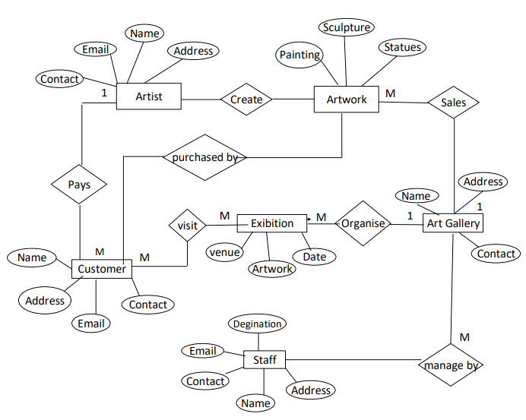

**Zero Level DFD:-**

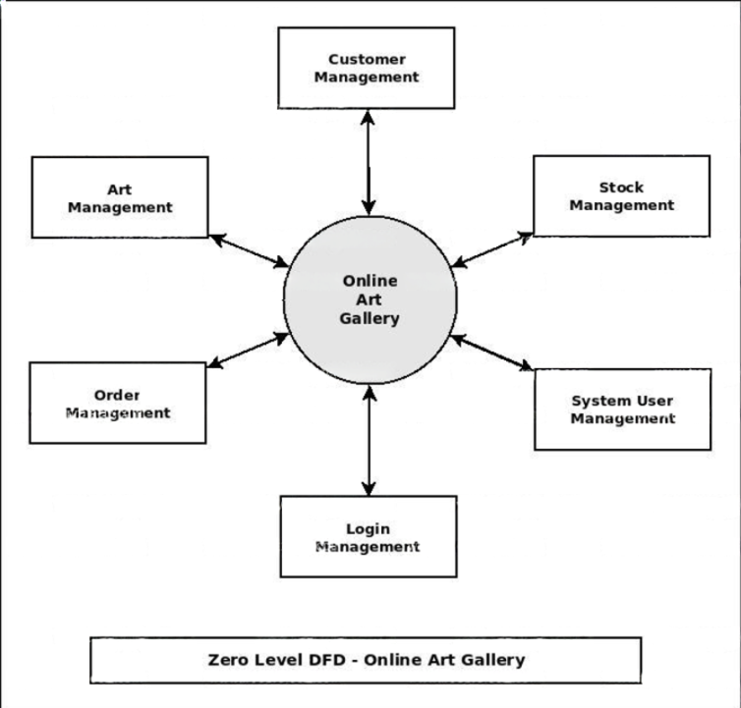

**First Level DFD :-**

**Second Level DFD :-**

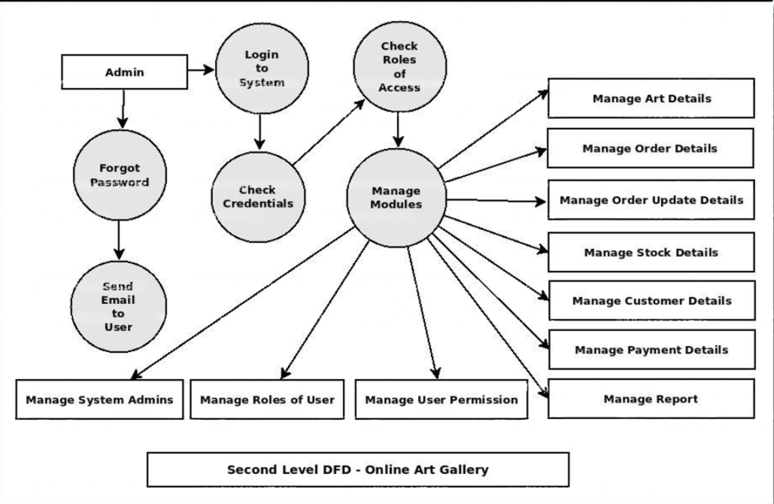

**Data Dictionary**

|  |  |  |  |  |
| --- | --- | --- | --- | --- |
| **Table Name:**  user | | | | |
| **Primary Key:** | | Sr.no | | |
| **Foreign Key:** | |  | | |
| **Table Description** | | It stores details of user which signup website | | |
| **Sr.no** | **Field Name** | **Data Type** | **Constraint** | **Description** |
| 1. | id | Int | Primary Key | Id of user |
| 2. | username | Varchar (100) | Unique Key | Name of user |
| 3. | password | Varchar (100) | Not Null | Password of user |
| 4. | Artist_name | Date and time | Current time | Name of artist |

|  |  |  |  |  |
| --- | --- | --- | --- | --- |
| **Table Name:**  paintings | | | | |
| **Table Description** | | It stores details and types of Painting | | |
| **Sr.no** | **Field Name** | **Data Type** | **Constraint** | **Description** |
| 1. | id | Int | Primary Key | Id of sculpture |
| 2. | title | Varchar (100) | Not Null | Title of paintings |
| 3. | artist | Varchar (100) | Not Null | Name of Artist |
| 4. | Price | Int | Null | Price of paintings |
| 5. | description | Varchar (100) | Not Null | Detail of paintings |
| 6. | image_path | Varchar (255) | Null | Paintings image path |

|  |  |  |  |  |
| --- | --- | --- | --- | --- |
| **Table Name:** Orders | | | | |
| **Table Description** | | Records user purchases of paintings | | |
| **Sr.no** | **Field Name** | **Data Type** | **Constraint** | **Description** |
| 1. | Id | Int | Primary Key | Id of Painting |
| 2. | User id | Int | Not Null | Name of user |
| 3. | Painting_id | Int | Not Null | Name of painting id |
| 4. | Purchase_date | TimeStamp | Default | Purchase date of Painting |
| 5. | status | Varchar (20) | Default | Status of Painting |

|  |  |  |  |  |
| --- | --- | --- | --- | --- |
| **Table Name:** Contact us | | | | |
| **Table Description** | | It stores details of Wall Painting | | |
| **Sr.no** | **Field Name** | **Data Type** | **Constraint** | **Description** |
| 1. | Id | Int | Primary Key | Id of customer |
| 2. | Name | Varchar (100) | NULL | Name of customer |
| 3. | Email | Varchar (100) | NULL | Email of customer |
| 4. | Message | TEXT | NULL | Message from customer |
| 5. | Created_at | TIMESTAMP | Default | Date contacted by customer |

|  |  |  |  |  |
| --- | --- | --- | --- | --- |
| **Table Name:** Admin | | | | |
| **Table Description** | | Manages user registration, authentication, and profiles. | | |
| **Sr.no** | **Field Name** | **Data Type** | **Constraint** | **Description** |
| 1. | Id | Int | Primary Key | Id of Admin. |
| 2. | username | Varchar | Not Null | UserName of admin. |
| 3. | email | Varchar | Not Null | Email of admin. |
| 4. | password | Varchar | Not Null | Password of admin . |

|  |  |  |  |  |
| --- | --- | --- | --- | --- |
| **Table Name:** About Page | | | | |
| **Table Description** | | Holds the main content text for the About page | | |
| **Sr.no** | **Field Name** | **Data Type** | **Constraint** | **Description** |
| 1. | Id | Int | Primary Key | Id of about us . |
| 2. | content | TEXT | Null | Main textual content for the About page |

* **Implementation Details**
* **Software & Hardware Requirement:**

**Client-Side:**

* Processor: AMD Ryzen 7 5700U with Radeon Graphics
* RAM: 16GB.
* Hard Disk: 512GB.
* Devices: Computer, Laptop etc...
* Browsers: Latest upgraded any browser like Chrome, opera, Safari etc.

**Server-Side:**

* + Processor: AMD Ryzen 7 5700U with Radeon Graphics 1.80 GHz
  + RAM: 16
  + Hard Disk: 512GB
  + Data Base Server: PhpMyAdmin
  + Language: PHP 3.3.0
* **Development-Side** :
* Client Side: HTML5, CSS3, JavaScript
* Sever Side Language: Python 3.13 with Flask 2.x
* Data Base Server: XAMPP SERVER(My SQL)
* Operating System: Windows 10 or above
* Editors: Visual Code and Notepad
* Browser: Latest upgraded any browser like Chrome,

Chrome, Safari, Internet Explorer, Opera etc.

* **User Interface**
* Artist Sign up Page

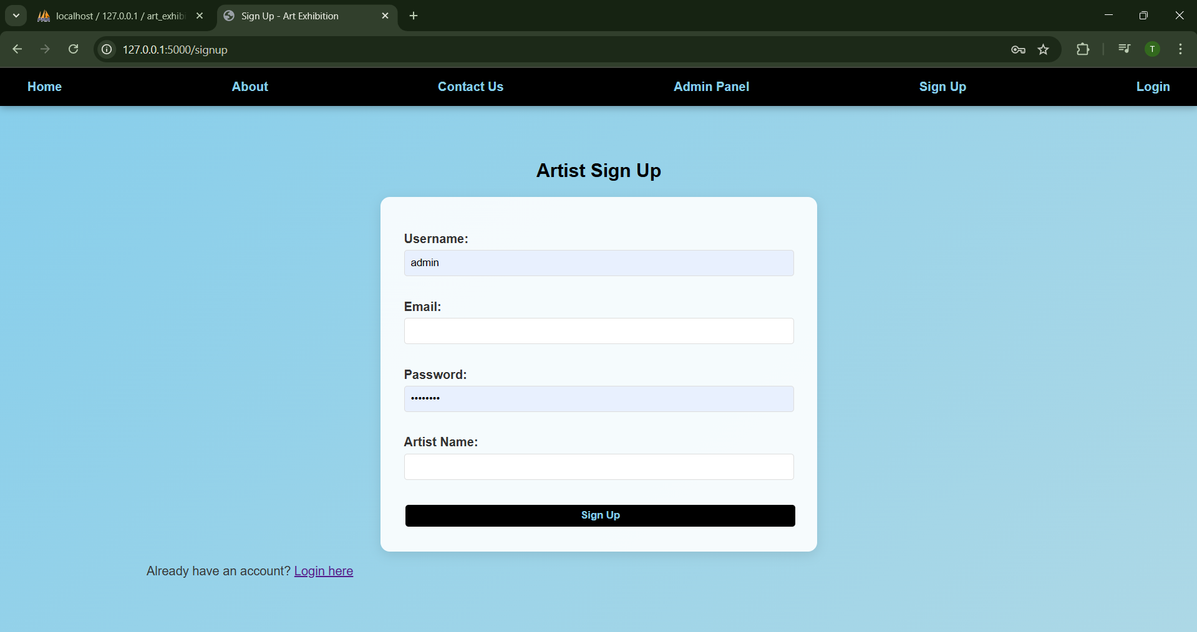

* Login Page

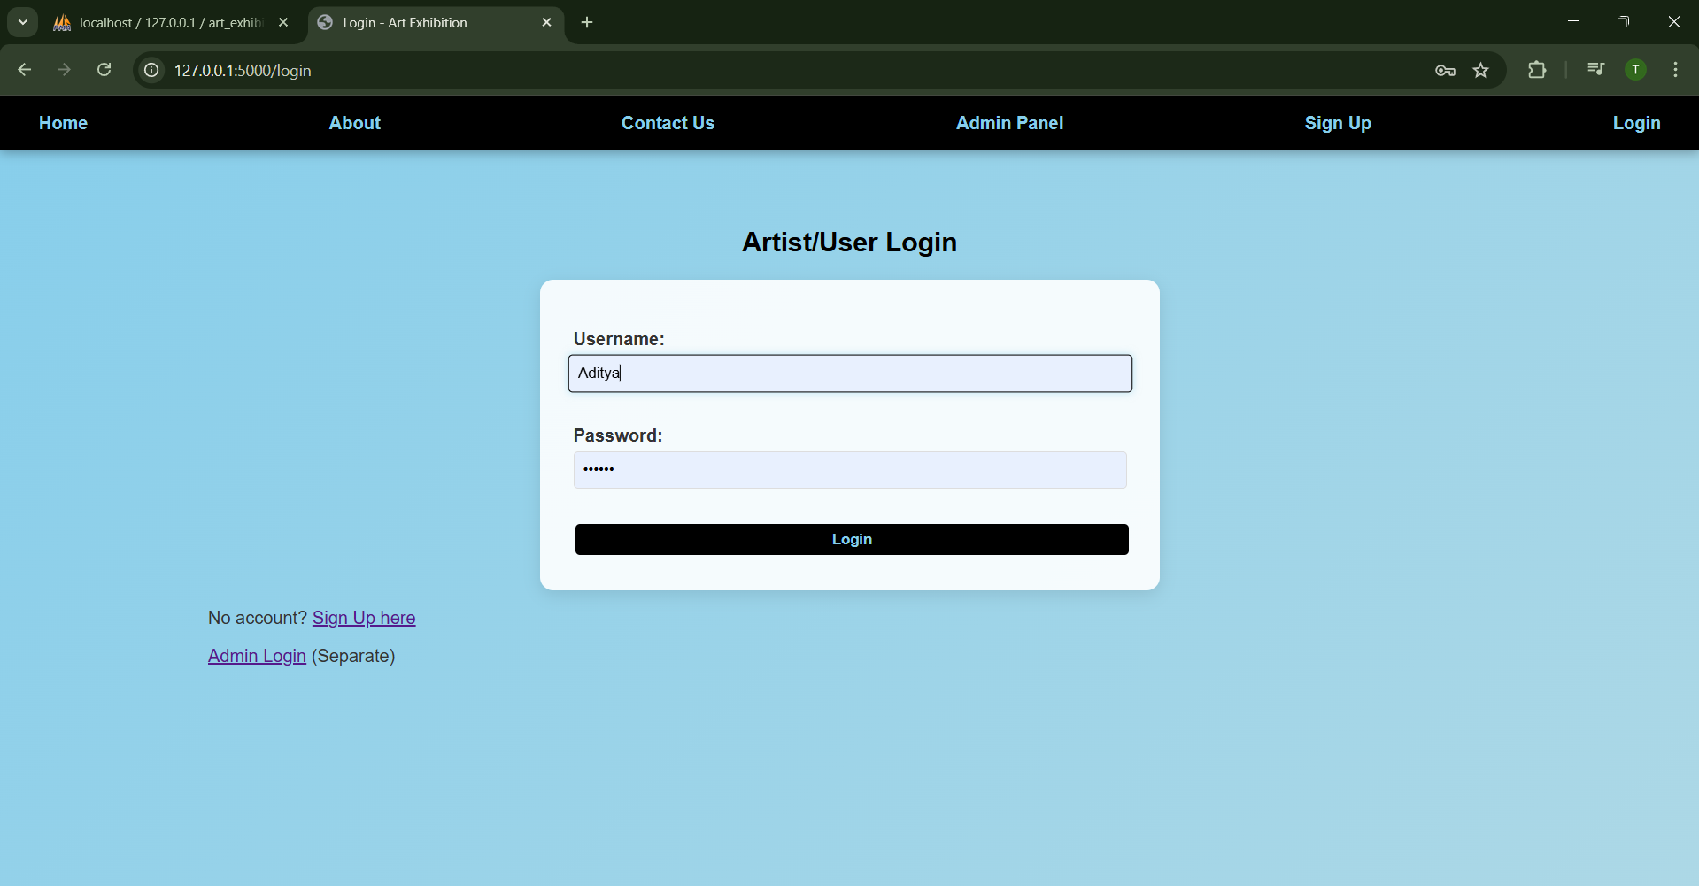

* Home

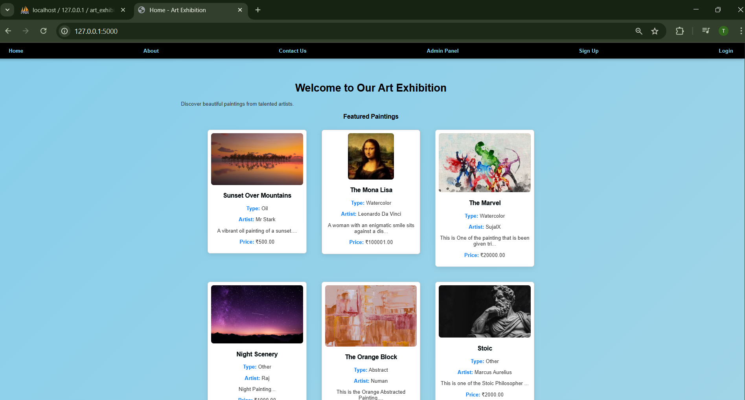

* **Painting Types: -**
* Watercolor Painting

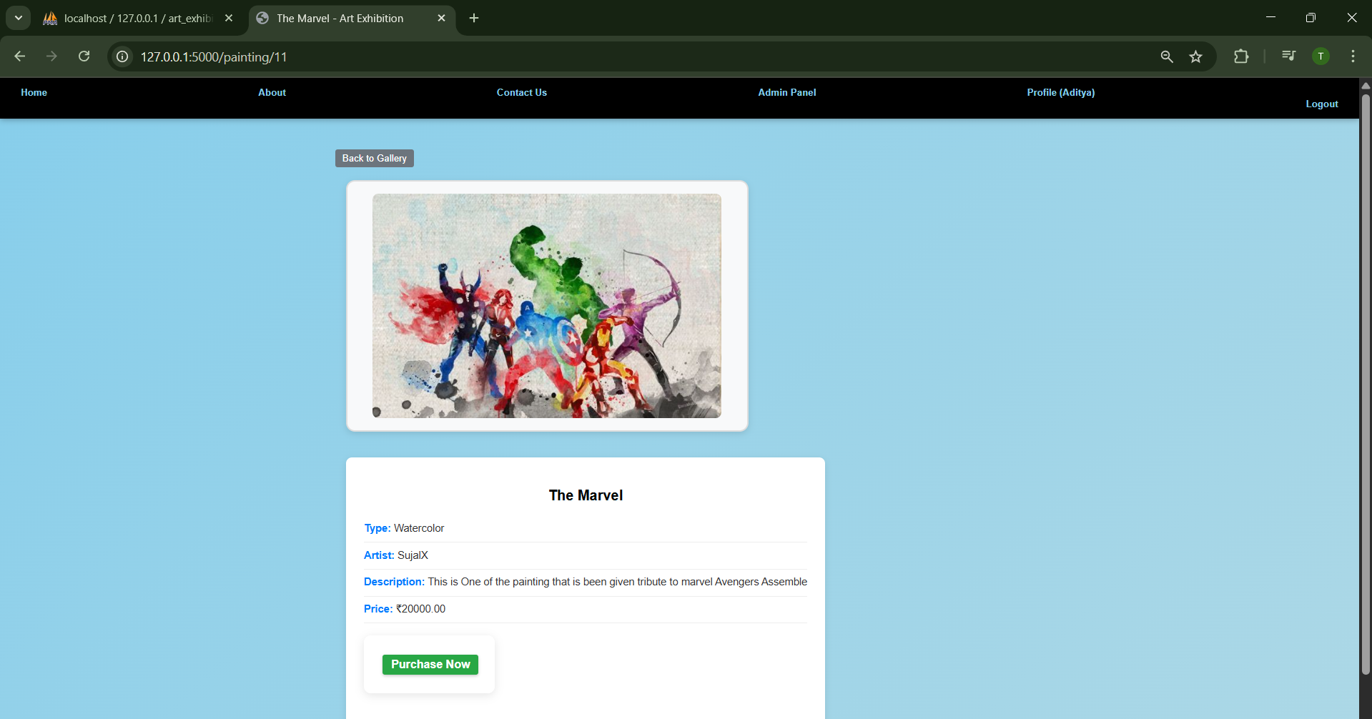

* Oil Paintings

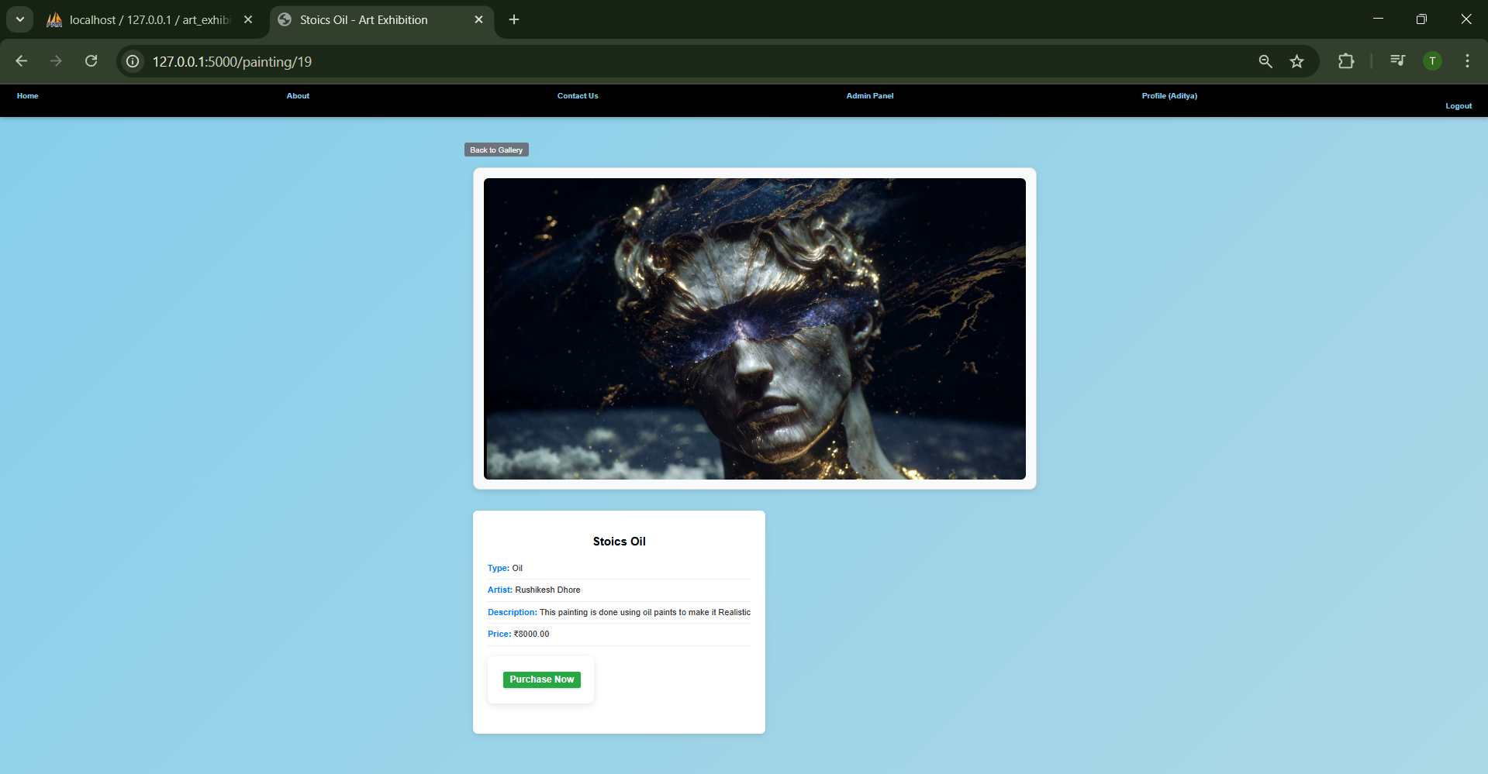

* Abstract Paintings

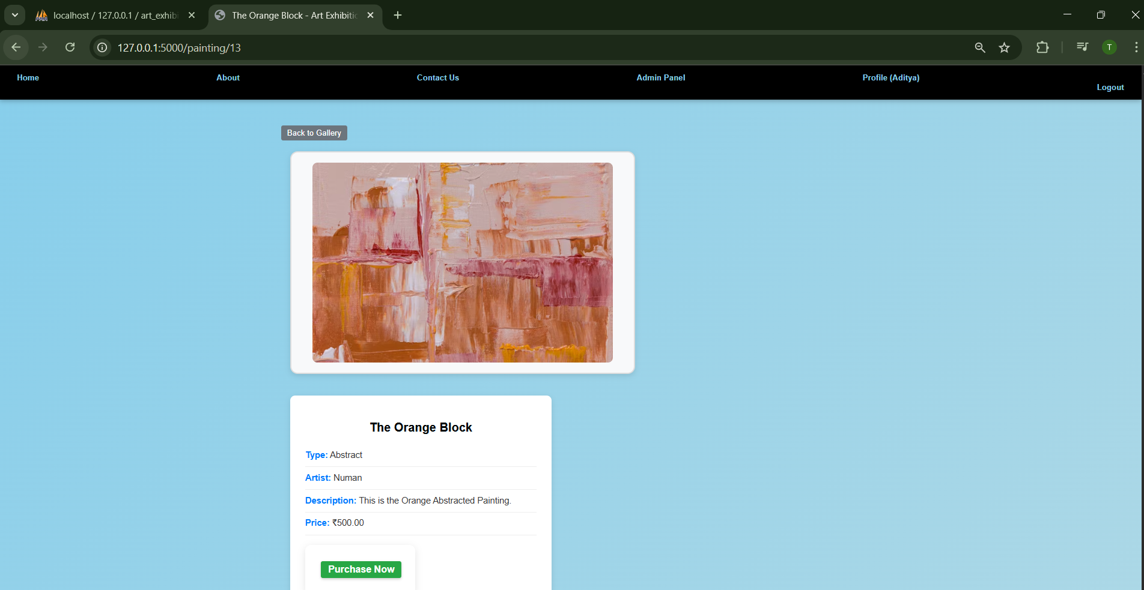

* About Us Page

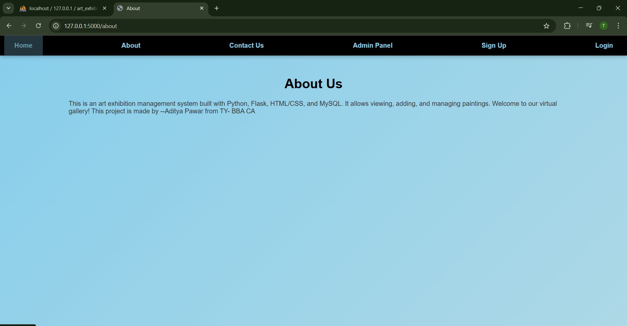

* Contact Us Page

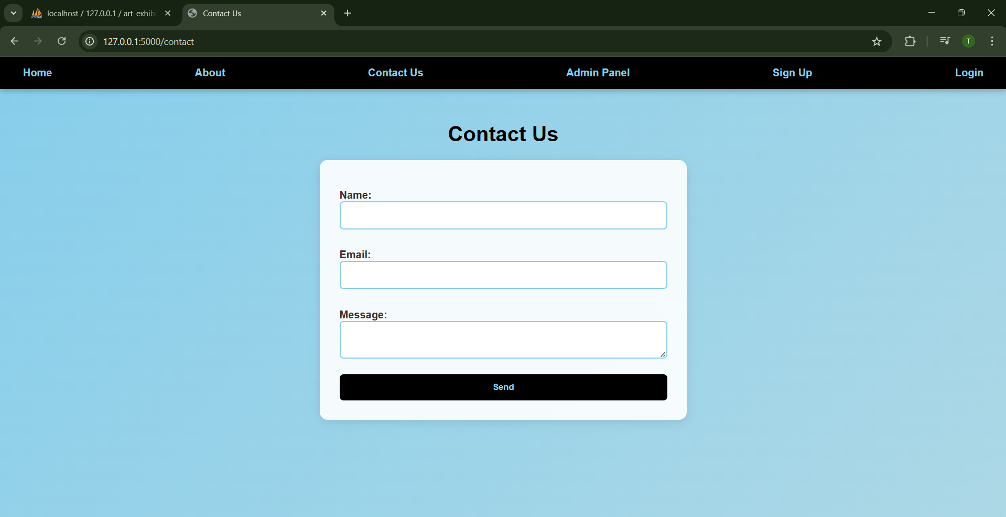

* Admin Login Page

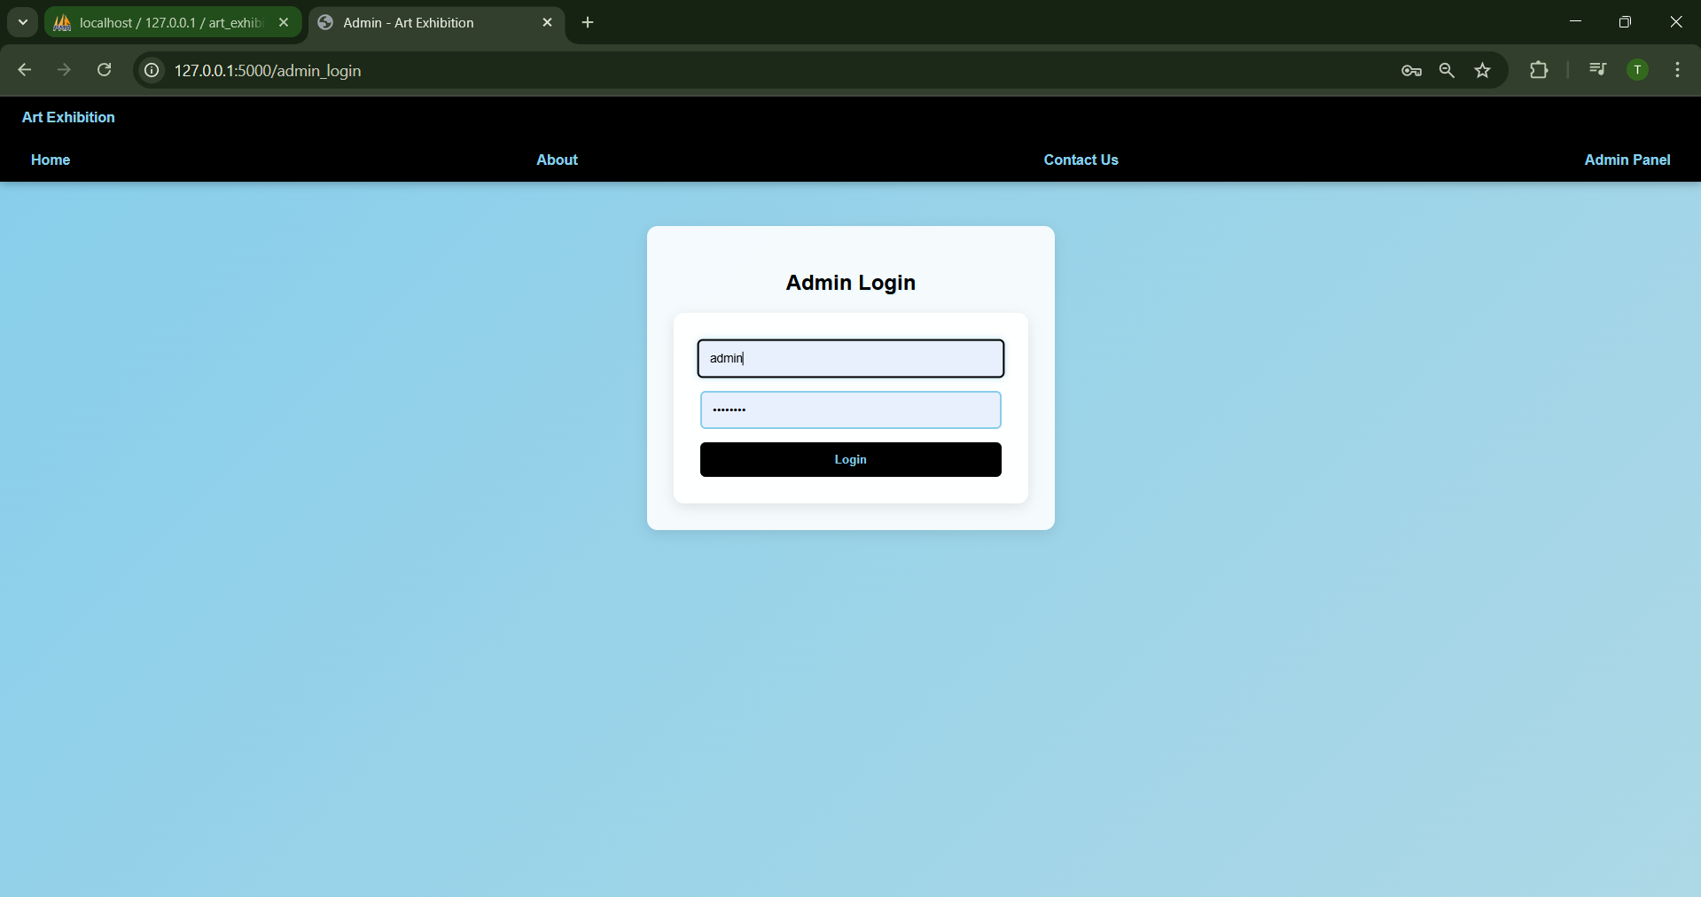

* Add Paintings page

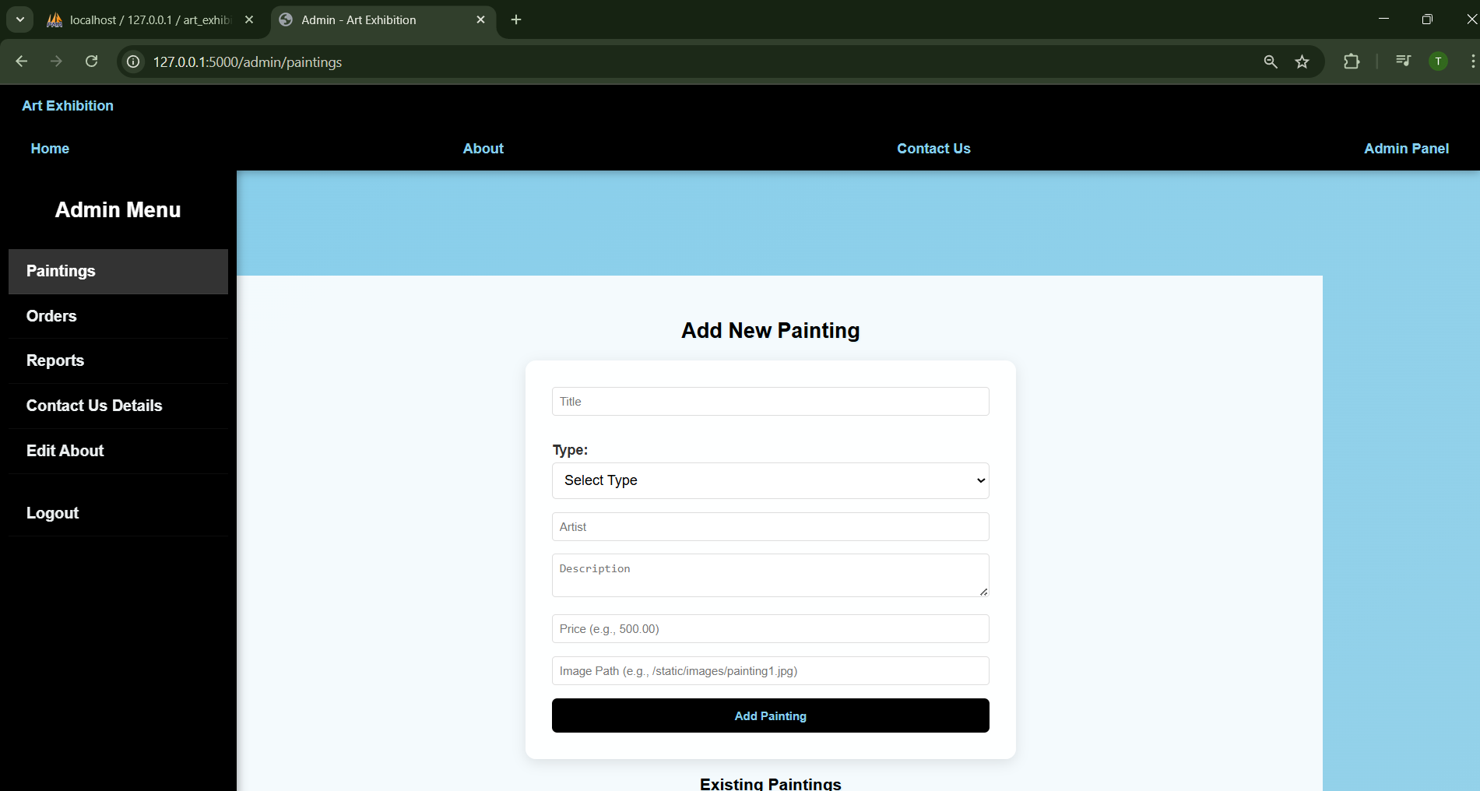

* Orders Page

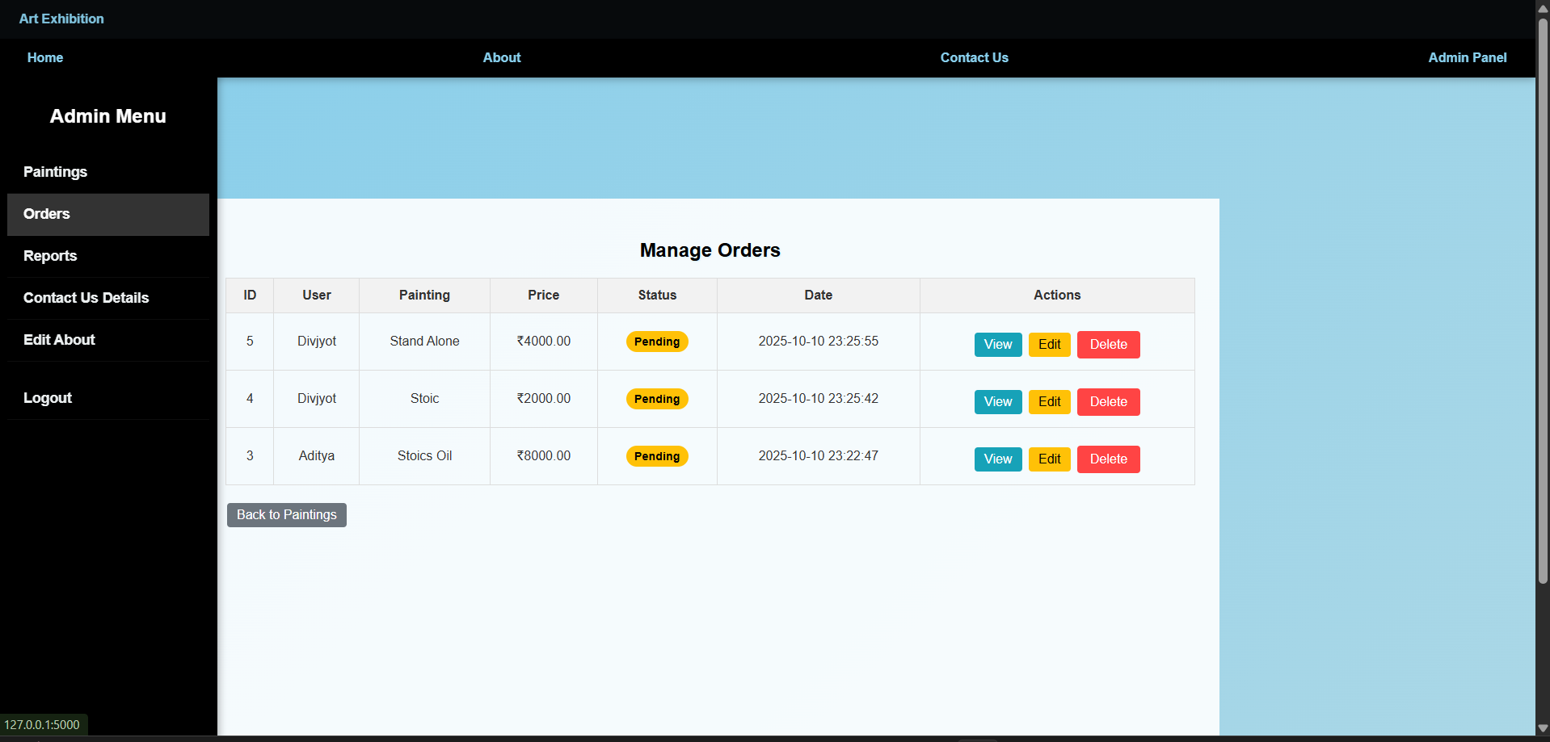

* Paintings Report

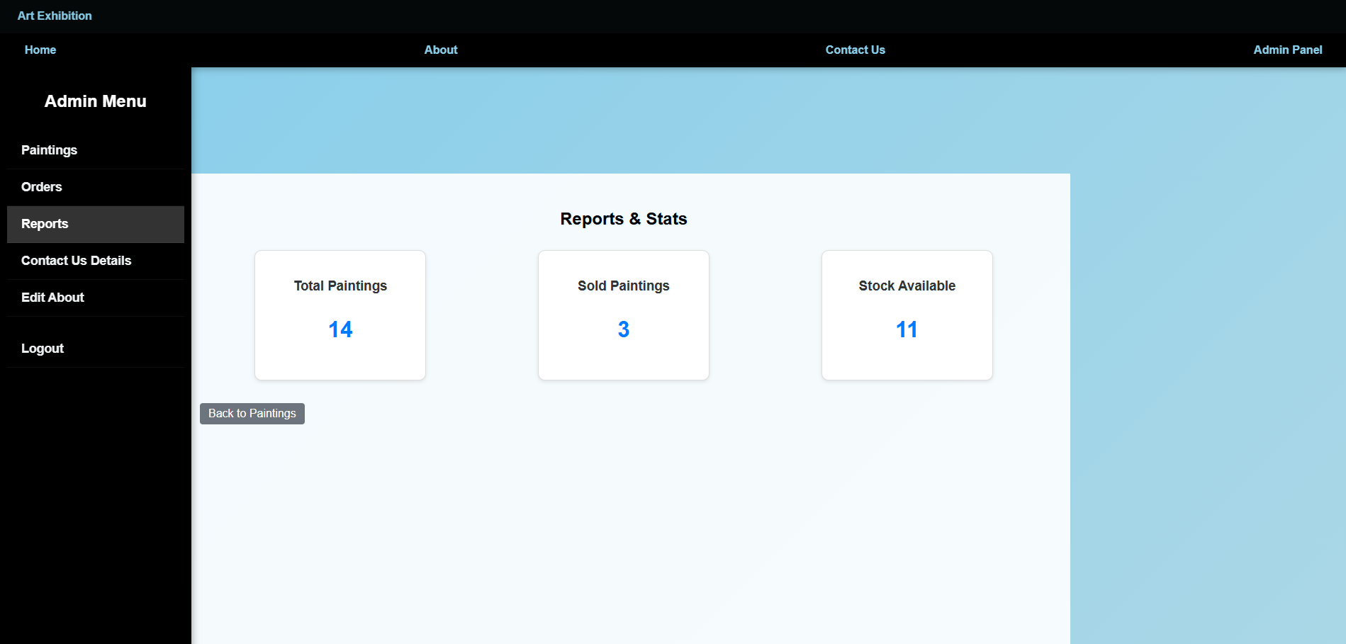

* **Contact Us Details**

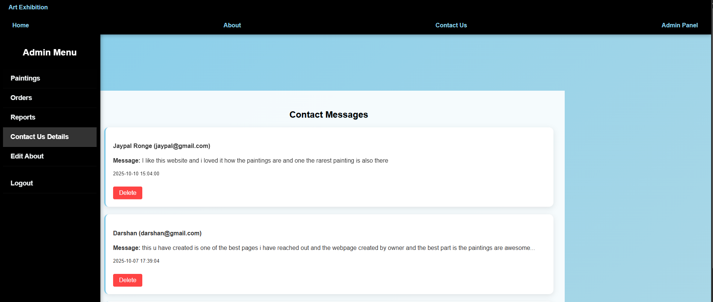

**About Page Edit**

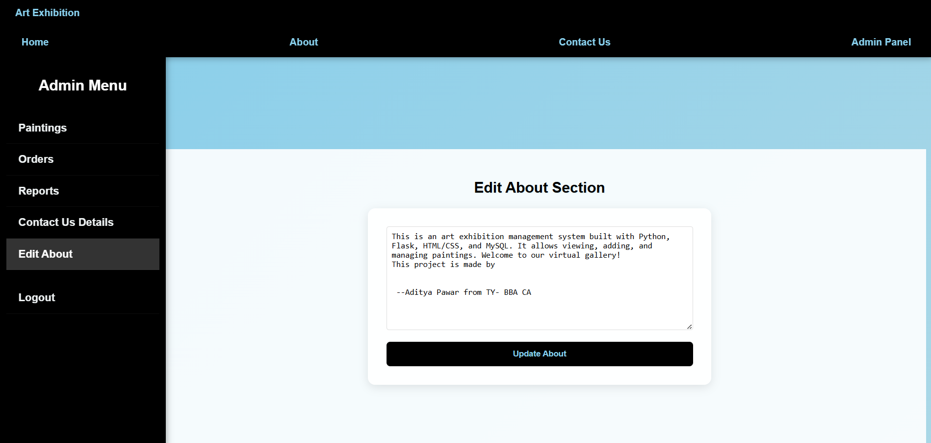

**Report Testing :-**

TESTING After all phase have been perfectly done, the system will be implemented to the server and the system can be used. Testing is yhe process of analysing a software item to detect the differences between existing and required conditions and to evaluate the features of software item. The system is tested under adverse situation and environment to test its performance, reliability and robustness. Verification and Validation is done for the system and it is reviewed against each and every customer requirement specification.

Types Of Testing:-

**White Box Testing**

This is a method of testing software that tests internal structures or working of an application, as opposed to its functionality, Internal program logic is exercised using this technique. The tester chooses inputs to exercise paths through the code and determine the appropriate outputs. This can be applied at the unit, integration and system levels of software testing process.

**Black box Testing**

Testing Black box testing is a method of software testing that examines the functionality of an application without peering into its internal structures and working. Software requirements are exercised using this technique. This method can be applied to every level of software testing

**Validation Testing**

The process of evaluating software during the development process or at the end of the development process to determine whether it satisfies specified business requirements. Validation Testing ensures that the product actually meets the client's needs. It can also be defined as to demonstrate that the product fulfils its intended use when deployed on appropriate user requirement.

**Future Enhancement**

The Art Exhibition Management System has been designed to override the problem of the existing manual system. This web application is supported to eliminate and, in some cases, reduce the hardship faced by manual systems.

The application is reduced as much as possible to avoid errors while entering the data. It also provides a message while entering invalid data. No formal knowledge is required for the user to operate this system. Overall, we said that Art Exhibition Management System project in PYTHON is user-friendly.

There is always improvements in any software package. However good or efficient it might be. Not the important thing is that the system should be flexible enough for future modification / alterations whenever and whomever it might be. Considering this important factor, the system is designed in such a way, the software is developed in modules that are efficient enough to introduce any changes in the software to get more information. Similarly, the present system can be implemented on internet/online and software can be connected to the various branches of the Enterprises with security constraints added to it.

We want to do following enhancement in projects.

• Some of the limitation is removed by using some advance technology in future.

• We can also add some additional features so that admin functionality will be less.

• More advanced techniques can be added for this system to make the

admin look after the inventory.

**CONCLUSION**

I would like to admit that there was a lot of efforts involved in developing the ART EXHIBITION MANAGEMENT software. The completion time for the report was a long as that of the program. My project is only a humble venture to satisfy the needs in a institution. Several user-friendly coding has also been adopted. This package shall prove to be a powerful package in satisfying all the requirements of the users. The objective of software planning is to provide a frame work that enables the manager to make reasonable estimates to make within a limited time frame at the beginning of the software project and should be updated regularly as the project

progress.

The scope of the project has been described and can be extended to give flexibility of performing the maintaining of details. Achievements expected through the projects

• Comparing to existing system it performs at a faster pace.

• System gives better feedback.

• Timely and accurate information are available.

• The system provides greater processing speed consistency.

• Provides high security to system and hence unauthorised user can be prevented.

• The interface is very user friendly.

**BIBLIOGRAPHY**

**Reference Books**

• “ Core JavaScript ”- by R. Nageswara Rao

• “A Byte of Python”-by C.H.Swaroop

• “Taming JavaScript”-by Jeeva Jose

• “CSS crash course”-by Eric Matthes

• “CSS Pocket Reference”-by Mark Lutz

• “Database Management System”-by Ramakrishnan Gherke • • “Database

Management System”- by Ashwini S Diwakar.

• “Software Engineering”- by Ashwini S Diwakar.

**Referred websites:-**

• www.youtube.com

• https://geeks.org/

• www.wikipedia.com

• www.programmingknowledgeblog.blogspot.com

• www.tutorialspoint.com

• https://python.com/tutorials

• [https://www.geeksforgeeks.org/javascript-beginner-to-advanced](https://www.geeksforgeeks.org/javascript-beginner-to-advanced.)